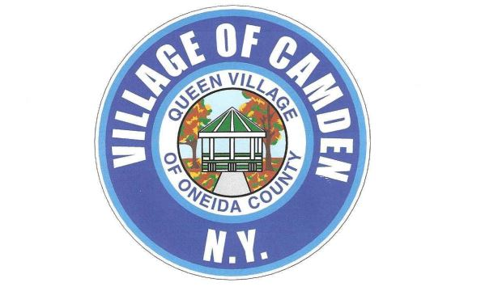
Notice of unknown water service line material
Dear Valued Consumer,
We are focused on delivering clean drinking water and protecting the health of every household in our community. This notice contains important information about your drinking water service connection. Please share this information with anyone who consumes food or drinks water at this property.
The figure below provides a visual representation of the service line. Please note, this is not a true representation of your service line, but an example of a common scenario.
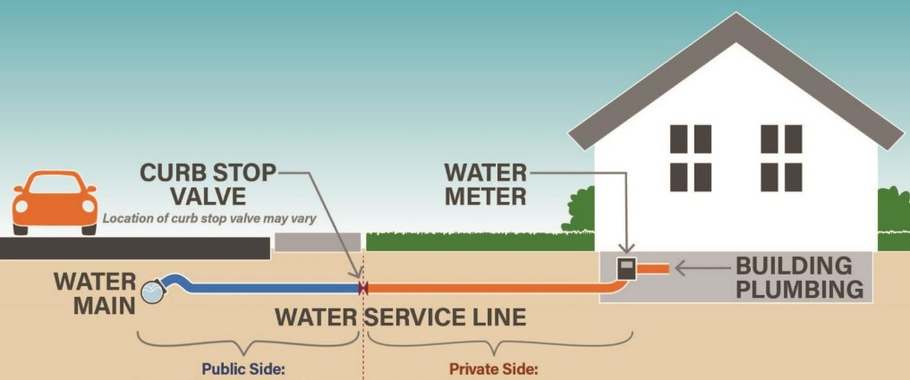
Throughout our water system, we have been working hard to identify the material of every service line (or pipes) delivering water to the structure(s) on a property from the water main. We have been unable to confirm the material of your service line at this time. Because the material is unknown and could be lead or a galvanized material that was previously connected to lead, we want to inform you of the potential risks from lead exposure in drinking water.
Identifying service line material
We need your help in order to determine the material of your service line.
Please contact us at:
Camdendpw245@yahoo.com [enter into email subject matter- EPA Lead Service]
Or Call (315)245-0560

The EPA has developed an online step-by-step guide to help people identify lead pipes in their homes called Protect Your Tap: A Quick Check for Lead. It is available for viewing at: https://www.epa.gov/ground-water-and-drinking-water/protect-your-tap-quick-check-lead
Health effects of lead
Exposure to lead in drinking water can cause serious health effects in all age groups. Infants and children can have decreases in IQ and attention span. Lead exposure can lead to new learning and behavior problems or worsen existing problems. The children of women who are exposed to lead before or during pregnancy can have increased risk of these negative health effects. Adults can have an increased risk of heart disease, high blood pressure, and kidney or nervous system problems.
Steps you can take to reduce the risk of lead in drinking water
Below are recommended actions that you may take, separately or in combination, if you are concerned about lead in your drinking water. The list also includes where you may find more information and is not intended to be a complete list or to imply that all actions equally reduce lead in drinking water.
Use a water filter certified to remove lead. Using a filter can reduce lead in drinking water. If you use a filter, it should be certified to remove lead. Read instructions provided with the filter thoroughly to ensure correct installation, maintenance and replacement timeframe. Using a cartridge after it has expired can reduce its effectiveness.
Clean your aerator. Regularly clean your faucet's screen (also known as an aerator). Sediment, debris, and lead particles can collect in your aerator. If lead particles are caught in the aerator, lead can get into your water.
Use cold water. Do not use hot water from the tap for drinking, cooking, or making baby formula as lead dissolves more easily into hot water. Boiling water does not remove lead from water.
Run your water. The more time water has been sitting in pipes providing water to your home, the more lead it may contain. Before drinking, flush your home's pipes by running the tap, taking a shower, doing laundry, or doing a load of dishes. The amount of time to run the water will depend on the material, length and diameter of your service line and the amount of internal plumbing in your home.
Get your child tested to determine lead levels in their blood
Although there is no confirmation of having a lead service line, if you are concerned about potential exposure, you may wish to speak with a healthcare provider to see if your child's lead level is elevated and or if there is a need for blood testing. For more information on reducing lead exposure from your drinking water and the health effects of lead, visit the EPA's website at http://www.epa.gov/lead
This notice is being sent to you by: Village of Camden
State Water System ID: NY3202385
Date Notice Distributed: November 1, 2024

